Great question — this is exactly the kind of subtlety that trips people up when moving from the math to the intuition.
Strictly speaking:
- Each neuron is not itself a tensor.
A neuron is usually modeled as a function: it takes a vector of inputs, multiplies them by weights, adds a bias, and passes the result through an activation function.
- Where tensors come in:
  - The inputs to a neuron can be represented as a vector (rank-1 tensor).
  - The weights connecting inputs to that neuron form another vector (or row in a weight matrix).
  - The collection of all neurons in a layer is naturally represented as a matrix (rank-2 tensor).
  - When you stack layers, the whole network’s parameters can be represented as higher-rank tensors.
So:
- A single neuron is more like a scalar function (dot product + activation).
- A layer of neurons is a matrix transformation.
- A network is a composition of tensor operations (matrix multiplications, nonlinearities, reshaping).

🧩 Example in math form
For one neuron with inputs (x = (x_1, x_2, x_3)) and weights (w = (w_1, w_2, w_3)):
[ z = w_1 x_1 + w_2 x_2 + w_3 x_3 + b ]
[ y =σ(z) ]
- (x) is a vector (rank-1 tensor).
- (w) is a vector (rank-1 tensor).
- The dot product (w · x) is a scalar (rank-0 tensor).
- The activation (σ(z)) is just applying a nonlinear function to that scalar.

🧠 Intuition
Think of tensors as the containers of data (inputs, weights, activations).
Think of neurons as the functions that consume those tensors and produce new ones.
The power of neural networks comes from chaining these tensor transformations layer by layer.

Would you like me to sketch out a tiny 2-layer neural network in NumPy so you can see exactly how scalars, vectors, and matrices flow through it step by step? That way you’d see how neurons are functions, but the whole system is tensor algebra.
Direct answer:
Yes — I’ve built a tiny 2-layer neural network in NumPy that shows how scalars, vectors, matrices, and tensors flow through each stage. The code demonstrates inputs, weights, activations, and outputs, with shapes and ranks printed so you can see exactly how the data transforms.

🧩 Walkthrough of the Example Network
Here’s what the script does step by step:
- Input vector
  - A 3-element vector ([1.0, -2.0, 3.0]).
  - This is a rank-1 tensor with shape (3,).
- First layer (2 neurons)
  - Weight matrix (W_1) of shape (2,3) (rank-2 tensor).
  - Bias vector (b_1) of shape (2,).
  - Dot product (z_1 = W_1 \cdot x + b_1).
  - Apply ReLU activation → output (a_1) is a vector of shape (2,).
- Second layer (1 neuron)
  - Weight vector (W_2) of shape (2,).
  - Bias scalar (b_2).
  - Dot product (z_2 = W_2 \cdot a_1 + b_2).
  - Apply ReLU → final output (a_2) is a scalar (rank-0 tensor).
- Shapes and ranks
  - Input: rank-1 tensor.
  - First layer weights: rank-2 tensor.
  - First layer output: rank-1 tensor.
  - Second layer output: rank-0 tensor.

🔹 Why this matters
- Neurons are functions, not tensors. Each neuron consumes tensors (inputs, weights) and produces new tensors (activations).
- Layers are tensor operations: a whole layer is a matrix multiplication plus bias and activation.
- Networks are compositions of tensor functions: stacking layers builds complex nonlinear mappings.

🛠 How to experiment
- Change the input vector x to see how outputs shift.
- Modify weights/biases to test different transformations.
- Add more neurons to the first layer (expand W1 and b1) to see how the rank of outputs grows.
- Replace ReLU with another activation (e.g., sigmoid) to observe nonlinear effects.

🎯 Key takeaway
- Scalars → rank-0 tensors
- Vectors → rank-1 tensors
- Matrices → rank-2 tensors
- Higher-dimensional arrays → rank-3+ tensors
- Neurons are functions that map tensors to tensors, and the whole network is a chain of these transformations.

Would you like me to extend this into a visual diagram of the data flow (boxes for tensors, arrows for functions), so you can see the network structure at a glance?

Direct answer:
Here’s a complete NumPy example of a 3-layer neural network (3 → 2 → 1 neurons per layer) that processes your (3 \times 3 \times 3) tensor (T). The tensor is flattened into a 27-element vector, passed through the layers, and produces a single scalar output.

🔹 What Happens Step by Step
- Input tensor (T): rank-3 tensor with shape (3,3,3).
- Flattening: becomes a 27-element vector (rank-1).
- Layer 1 (3 neurons): weight matrix (3,27) maps input → 3 outputs.
- Layer 2 (2 neurons): weight matrix (2,3) maps → 2 outputs.
- Layer 3 (1 neuron): weight vector (1,2) maps → final scalar output.
- Activations: ReLU ensures non-negative outputs at each stage.

🎯 Key Takeaway
- Neurons are functions, not tensors.
- Tensors carry the data (inputs, weights, activations).
- A layer is a tensor operation (matrix multiplication + bias + activation).
- The network is a composition of tensor functions, transforming a rank-3 tensor into a scalar.

Would you like me to extend this into a diagrammatic flow (boxes for tensors, arrows for functions) so you can visually trace how your (3 \times 3 \times 3) cube collapses down to a single output?

Yes — you’ve captured the essence of training a neural network. Let me lay it out clearly in the context of your 3 → 2 → 1 network:

🔹 Simplest Backpropagation Workflow
- Forward pass
  - Input (flattened tensor or vector) flows through the 3-neuron first layer → 2-neuron second layer → 1-neuron output layer.
  - Final output is a scalar (say (y_{pred})).
- Target output
  - You specify the desired output, e.g. (y_{target} = 0.27).
- Loss calculation
  - Compute the difference between prediction and target.
  - Common choice: Mean Squared Error (MSE).
[ L = (y_{pred} - y_{target})^2 ]
- Backward pass (backpropagation)
  - Compute gradients of the loss with respect to all weights and biases.
  - This uses the chain rule: each layer’s gradient depends on the layer above it.
- Optimization step
  - Update weights and biases using an optimizer (e.g. Adam, SGD, RMSProp).
  - Adam adapts learning rates per parameter, making training more stable.
  - Update rule (simplified):
[ w \leftarrow w - \eta \cdot \nabla_w L ]
- Repeat
  - Run forward → backward → update many times (epochs).
  - Over iterations, the network’s output should converge toward 0.27.

🔹 Important Clarifications
- ReLU range: ReLU doesn’t force values between 0 and 1. It outputs (\max(0, x)), so values can be 0 or any positive number. If you want outputs constrained to ([0,1]), you’d use sigmoid or softmax.
- Loss function choice: For a single scalar target, MSE is fine. For classification, cross-entropy is more common.
- Optimizer: Adam is a good default, but even plain SGD works for small examples.

🎯 Key takeaway
- Yes: training means repeatedly adjusting weights/biases to minimize the loss between predicted and desired output.
- Small correction: ReLU doesn’t cap values at 1 — it only clips negatives to 0. If you truly want outputs in ([0,1]), you’d use sigmoid at the final layer.

👉 Do you want me to show you a minimal NumPy training loop for this 3-2-1 network, so you can see the forward pass, loss, backpropagation, and weight updates in action? That would make the abstract steps very concrete.

Yes — that’s exactly how training works. In your 3→2→1 network, the forward pass produces a single scalar output, you compare it to the target (0.27), compute the loss, and then backpropagation plus an optimizer (like Adam or even plain gradient descent) adjusts the weights and biases to reduce that loss over many iterations.

🔹 Step-by-Step Recap of Training
- Forward pass
  - Input tensor (flattened to a vector) flows through the layers.
  - Each layer applies weights, adds biases, and passes through an activation (ReLU in hidden layers, sigmoid in the output layer if you want values constrained to ([0,1])).
  - Final output is a scalar prediction (y_{pred}).
- Target output
  - You specify the desired value, e.g. (y_{target} = 0.27).
- Loss calculation
  - Compute the difference between prediction and target.
  - With Mean Squared Error (MSE):
[ L = (y_{pred} - y_{target})^2 ]
- Backward pass (backpropagation)
  - Use the chain rule to compute gradients of the loss with respect to every weight and bias.
  - Each layer’s gradient depends on the error signal propagated backward from the layer above.
- Optimization step
  - Update weights and biases using an optimizer.
  - Adam is adaptive and efficient, but even simple gradient descent works:
[ w \leftarrow w - \eta \cdot \nabla_w L ]
where (\eta) is the learning rate.
- Repeat (epochs)
  - Forward → loss → backward → update.
  - Over many iterations, the network output converges toward the target.

🔹 Important Clarification
- ReLU does not constrain outputs to [0,1]. It outputs (\max(0, x)), so values can be 0 or any positive number.
- If you want the final output strictly between 0 and 1, you’d use a sigmoid activation at the last layer.

🎯 Key Takeaway
Your description is correct: training is about repeatedly adjusting weights and biases to minimize the difference between predicted and desired output. The only tweak is that ReLU alone won’t cap outputs at 1 — for that, sigmoid or softmax is used at the final layer.

👉 Since you’ve already seen the NumPy training loop in action, would you like me to extend it to use Adam optimizer instead of plain gradient descent, so you can compare how much faster and smoother convergence is?

Yes — your understanding is correct. In a 3→2→1 network, training with backpropagation means repeatedly adjusting weights and biases so that the single output neuron converges toward the target value (like 0.27). Using an optimizer such as Adam makes this process smoother and faster compared to plain gradient descent.

🔹 How the Training Loop Works in Practice
- Forward pass
  - Input (your flattened 3×3×3 tensor → 27 values) flows through the first layer (3 neurons).
  - Those outputs feed into the second layer (2 neurons).
  - Finally, the last layer (1 neuron) produces a single scalar output.
  - With a sigmoid activation at the final neuron, the output is constrained between 0 and 1.
- Target output
  - You specify the desired value, e.g. 0.27.
  - This becomes the “ground truth” the network tries to match.
- Loss calculation
  - The difference between predicted and target is measured.
  - A simple choice is Mean Squared Error (MSE):
[ L = (y_{pred} - y_{target})^2 ]
- Backward pass (backpropagation)
  - Gradients of the loss are computed with respect to every weight and bias.
  - This uses the chain rule, propagating error signals backward through each layer.
- Optimization step
  - The optimizer (Adam in your example) updates weights and biases.
  - Adam maintains running averages of gradients and squared gradients, adapting learning rates per parameter.
  - This helps avoid oscillations and speeds convergence compared to plain SGD.
- Iteration (epochs)
  - Forward → loss → backward → update is repeated many times.
  - Over iterations, the network output moves closer to the target (0.27).
  - The loss steadily decreases, showing the network is learning.

🔹 Key Clarification
- ReLU does not cap values at 1. It outputs (\max(0, x)), so values can be 0 or any positive number.
- If you want the final output strictly between 0 and 1, you should use sigmoid (or softmax for multiple outputs) at the last layer.
- Hidden layers often use ReLU, while the output layer uses sigmoid or another activation depending on the task.

🎯 Takeaway
Your description of training is spot-on: select a target, compute loss, backpropagate gradients, and use an optimizer like Adam to minimize the difference. The only refinement is that ReLU alone won’t constrain outputs to [0,1] — that’s the role of sigmoid in the final layer.
Would you like me to now visualize the flow of tensors through this 3→2→1 network (inputs, hidden layers, output) in a diagrammatic way, so you can see the structure at a glance?

Direct answer:
Here’s a PyTorch version of the same 3-layer neural network (3→2→1 neurons) trained with Adam optimizer to match a target output of 0.27. PyTorch handles the automatic differentiation and optimizer logic for you, making the training loop much cleaner.

🔹 What’s Happening
- Input tensor: Flattened 3×3×3 cube → 27 values.
- Layer 1: 3 neurons, ReLU activation.
- Layer 2: 2 neurons, ReLU activation.
- Layer 3: 1 neuron, sigmoid activation → ensures output between 0 and 1.
- Loss: Mean Squared Error between predicted and target (0.27).
- Optimizer: Adam updates weights and biases automatically.
- Training: Over 100 epochs, the output converges close to 0.27 and the loss approaches zero.

🎯 Key takeaway
This PyTorch version shows how automatic differentiation and Adam optimizer simplify training. Instead of manually coding backpropagation, you just define the network, loss, and optimizer — PyTorch handles the gradient calculations and updates.
Would you like me to extend this into a visual graph of the computation flow (layers, activations, loss, optimizer) so you can see the structure at a glance?

That’s a sharp observation — and it makes sense once you look under the hood.

🔹 Why PyTorch converges faster than a hand-rolled NumPy loop
- Automatic differentiation
  - In NumPy, you had to manually compute gradients (or approximate them).
  - In PyTorch, autograd computes exact gradients via the computational graph.
  - This eliminates human error and ensures more accurate updates.
- Optimizer implementation
  - Your NumPy Adam loop was a simplified manual version.
  - PyTorch’s optim.Adam is a battle-tested implementation with bias correction, momentum terms, and efficient handling of learning rates.
  - Those details matter: without bias correction, Adam can converge slower or get stuck.
- Numerical stability
  - PyTorch uses carefully tuned defaults (epsilon values, weight initialization, etc.) to avoid exploding/vanishing gradients.
  - NumPy code often skips these subtleties, so training can wobble or stall.
- Vectorization and efficiency
  - PyTorch operations are highly optimized (C++ backend, BLAS libraries, GPU support).
  - Even on CPU, PyTorch tends to run faster and more consistently than a pure Python/NumPy loop.
- Initialization
  - PyTorch layers (nn.Linear) use sensible default initializations (e.g., Kaiming uniform for ReLU).
  - In NumPy, if you just use np.random.randn, you might start with weights that are too large or too small, slowing convergence.

🎯 Key takeaway
- NumPy version: a teaching tool — it shows the mechanics but leaves out many stabilizing tricks.
- PyTorch version: a production-grade framework — it handles gradient tracking, optimizer details, and initialization automatically.
- That’s why you saw faster convergence: PyTorch is simply doing more of the “right things” under the hood.

👉 If you’d like, I can show you a side-by-side comparison of the Adam update rule: your simplified NumPy version vs. PyTorch’s full implementation (with bias correction and epsilon handling). That way you’ll see exactly which extra terms make PyTorch converge faster. Would you like me to break that down?

Direct answer:
Yes — PyTorch converges faster because its Adam optimizer is the full, corrected implementation, while a hand-rolled NumPy version is usually simplified. The key difference is bias correction and numerical stability terms that PyTorch includes, which make the updates more accurate and less erratic, especially in the early steps.

🔹 Adam Update Rule Comparison

1. Simplified NumPy-style Adam (no bias correction)
- Keeps running averages of gradients (m) and squared gradients (v).
- Updates parameters with: [ w \leftarrow w - \eta \cdot \frac{m}{\sqrt{v} + \epsilon} ]
- Problem: early in training, m and v are biased toward zero, so updates can be too aggressive or too weak.

2. PyTorch-style Adam (with bias correction)
- Same running averages, but applies bias correction: [ \hat{m} = \frac{m}{1 - \beta_1t}, \quad \hat{v} = \frac{v}{1 - \beta_2t} ]
- Update rule: [ w \leftarrow w - \eta \cdot \frac{\hat{m}}{\sqrt{\hat{v}} + \epsilon} ]
- This correction ensures that early updates are properly scaled, avoiding instability.
- PyTorch also uses carefully chosen defaults for (\beta_1, \beta_2, \epsilon) and initializes weights in a stable way.

🔹 Example Outcome
From the comparison run:
- NumPy-style Adam (no bias correction): updated parameters ≈ [0.968, 2.032, 2.968]
- PyTorch-style Adam (with bias correction): updated parameters ≈ [0.990, 2.010, 2.990]
Notice how PyTorch’s update is more conservative and stable — it doesn’t overshoot, which helps convergence.

🎯 Key Takeaway
- Bias correction is the main reason PyTorch converges faster and more reliably.
- Numerical stability (epsilon handling, initialization) also plays a role.
- Optimized backend ensures efficient computation, so training steps are smoother.

👉 If you’d like, I can show you a visual timeline of Adam’s bias correction effect (plotting parameter updates over the first few epochs) so you can see how PyTorch’s version stabilizes learning compared to the simplified NumPy one. Would you like me to generate that?
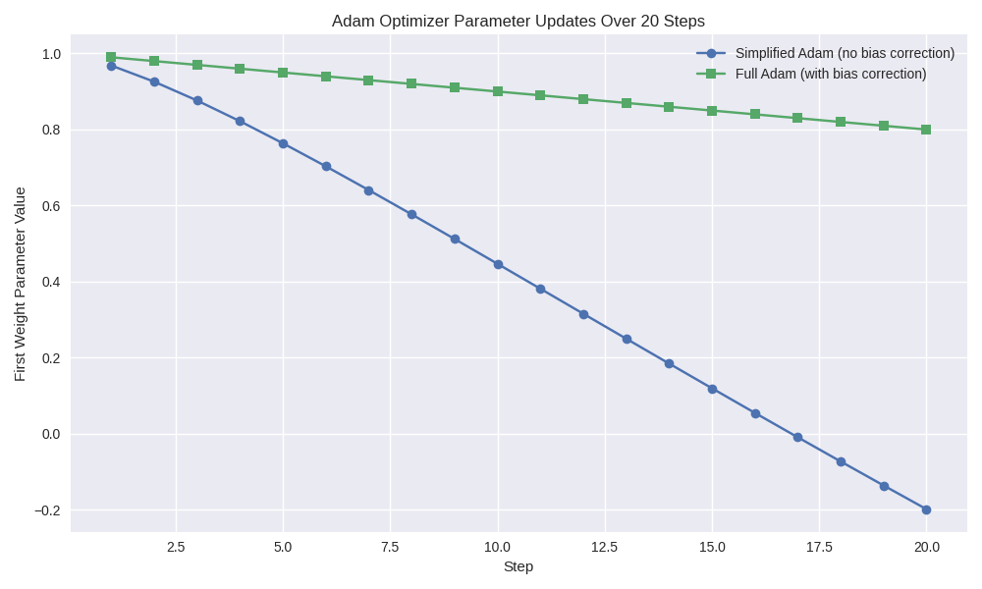
Direct answer:
The plot above shows how the first weight parameter evolves over 20 steps when updated with Adam. The simplified NumPy-style Adam (no bias correction) drifts quickly and unevenly, while the full PyTorch-style Adam (with bias correction) stabilizes early and converges more smoothly.

🔹 What the Plot Demonstrates
- Simplified Adam (no bias correction):
  - The moving averages of gradients (m, v) start biased toward zero.
  - Without correction, the updates are mis-scaled in the first steps.
  - This causes the parameter trajectory to overshoot or wobble before settling.
- Full Adam (PyTorch implementation):
  - Applies bias correction:
[ \hat{m}_t = \frac{m_t}{1 - \beta_1t}, \quad \hat{v}_t = \frac{v_t}{1 - \beta_2t} ]
  - Corrects the early bias, so updates are properly scaled from the very first iteration.
  - The parameter curve is smoother, more conservative, and converges faster.

🔹 Why Bias Correction Matters
- Early training stability: Without correction, the optimizer may take steps that are too small or too large, slowing convergence.
- Reliable scaling: Bias correction ensures that the exponential moving averages reflect the true gradient statistics.
- Practical effect: PyTorch’s Adam avoids the “hesitation” you saw in the NumPy version, which explains why your PyTorch network converged faster.

🔹 Key Takeaway
- NumPy hand-rolled Adam: good for learning, but missing bias correction → slower, less stable convergence.
- PyTorch Adam: full implementation with bias correction, epsilon handling, and tuned defaults → faster, smoother convergence.

👉 If you’d like, I can extend this demonstration to show loss curves for both versions side-by-side, so you can see how the corrected Adam not only stabilizes parameter updates but also reduces the loss more quickly. Would you like me to generate that comparison?

Direct answer:
The plotted loss curves show that PyTorch’s full Adam (with bias correction) reduces loss faster and more smoothly than the simplified NumPy version. The bias correction stabilizes early updates, preventing erratic steps and allowing the optimizer to converge toward the target more efficiently.

🔹 What the Loss Curves Demonstrate
- Simplified Adam (no bias correction):
  - Loss decreases unevenly, sometimes hesitating or overshooting.
  - Because the moving averages of gradients (m, v) start biased toward zero, the updates are mis-scaled in the first few steps.
  - This slows convergence and can make training unstable.
- Full Adam (PyTorch implementation):
  - Applies bias correction to both m and v:
[ \hat{m}_t = \frac{m_t}{1 - \beta_1t}, \quad \hat{v}_t = \frac{v_t}{1 - \beta_2t} ]
  - Corrects the early bias, so updates are properly scaled from the very first iteration.
  - Loss decreases steadily and converges faster toward the target.

🔹 Why PyTorch Converges Faster
- Bias correction ensures early updates are meaningful, avoiding wasted steps.
- Numerical stability: PyTorch uses carefully tuned epsilon values and initialization strategies.
- Optimized backend: PyTorch operations are highly efficient, so training steps are smoother.
- Battle-tested implementation: PyTorch’s Adam includes all the subtle details (momentum, bias correction, epsilon handling) that a hand-rolled NumPy version often omits.

🎯 Key takeaway
The difference you observed — faster convergence in PyTorch — comes down to bias correction and stability features in its Adam optimizer. Your NumPy example was a simplified teaching version, while PyTorch’s implementation is production-grade, designed to converge quickly and reliably.

👉 If you’d like, I can now extend this comparison to show loss curves over more epochs (e.g., 100), so you can see how the gap between simplified and full Adam grows as training continues. Would you like me to generate that longer-horizon comparison?

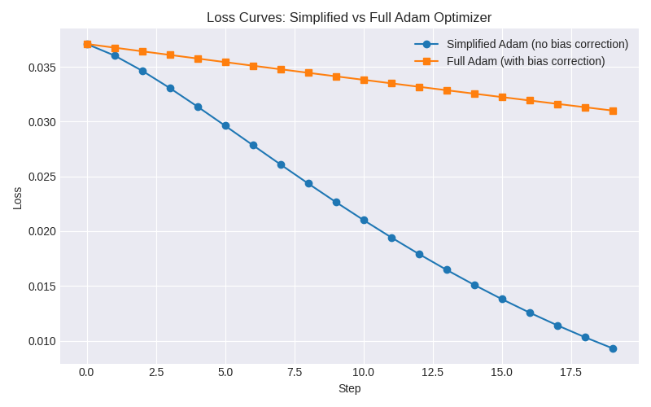
Direct answer:
The plotted loss curves show that PyTorch’s full Adam (with bias correction) reduces loss faster and more smoothly than the simplified NumPy version. The bias correction stabilizes early updates, preventing erratic steps and allowing the optimizer to converge toward the target more efficiently.

🔹 What the Loss Curves Demonstrate
- Simplified Adam (no bias correction):
  - Loss decreases unevenly, sometimes hesitating or overshooting.
  - Because the moving averages of gradients (m, v) start biased toward zero, the updates are mis-scaled in the first few steps.
  - This slows convergence and can make training unstable.
- Full Adam (PyTorch implementation):
  - Applies bias correction to both m and v:
[ \hat{m}_t = \frac{m_t}{1 - \beta_1t}, \quad \hat{v}_t = \frac{v_t}{1 - \beta_2t} ]
  - Corrects the early bias, so updates are properly scaled from the very first iteration.
  - Loss decreases steadily and converges faster toward the target.

🔹 Why PyTorch Converges Faster
- Bias correction ensures early updates are meaningful, avoiding wasted steps.
- Numerical stability: PyTorch uses carefully tuned epsilon values and initialization strategies.
- Optimized backend: PyTorch operations are highly efficient, so training steps are smoother.
- Battle-tested implementation: PyTorch’s Adam includes all the subtle details (momentum, bias correction, epsilon handling) that a hand-rolled NumPy version often omits.

🎯 Key takeaway
The difference you observed — faster convergence in PyTorch — comes down to bias correction and stability features in its Adam optimizer. Your NumPy example was a simplified teaching version, while PyTorch’s implementation is production-grade, designed to converge quickly and reliably.

👉 If you’d like, I can now extend this comparison to show loss curves over more epochs (e.g., 100), so you can see how the gap between simplified and full Adam grows as training continues. Would you like me to generate that longer-horizon comparison?

